Reflection

It is also called a mirror image of an object. For this reflection axis and reflection of plane is selected. Three-dimensional reflections are similar to two dimensions. Reflection is 180° about the given axis. For reflection, plane is selected (xy,xz or yz). Following matrices show reflection respect to all these three planes.

**Reflection relative to XY plane**

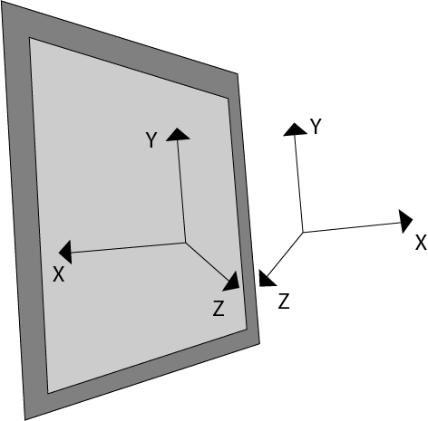  
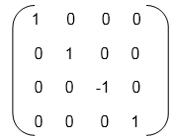

**Reflection relative to YZ plane**

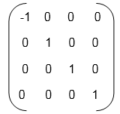

**Reflection relative to ZX plane**

